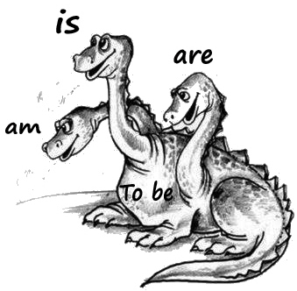
A. Complete the sentences with ¨to be¨.
1. I _____ a girl.
2. My father_____ from Australia.
3. Alex and Dino _____ my cats.
4. Alex _____ in the garden.
5. Dino _____ on the floor.
6. My red pencil _____ on the floor, too.
7. Blue and green pencils _____ in my pencil case.
8. My mother _____ in the living room.
9. Eli and Rafa _____ good friends.
10. They _____ good at tennis.
11. _____ they in the USA?
12. Children_____ at school.
13. It _____ Monday.
14. I _____ at home.
15. We _____ friends.
A. Complete the sentences with ¨to be¨.
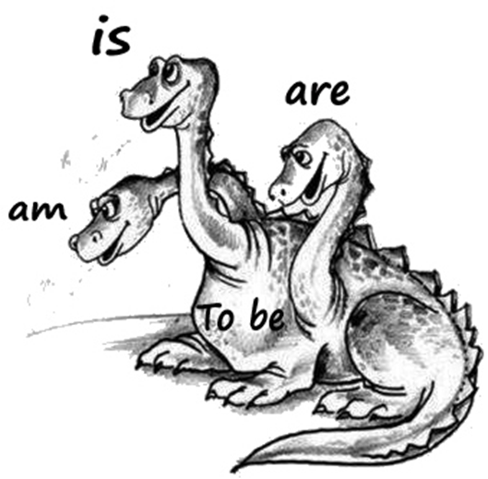
1. I _____ a girl.
2. My father_____ from Australia.
3. Alex and Dino _____ my cats.
4. Alex _____ in the garden.
5. Dino _____ on the floor.
6. My red pencil _____ on the floor, too.
7. Blue and green pencils _____ in my pencil case.
8. My mother _____ in the living room.
9. Eli and Rafa _____ good friends.
10. They _____ good at tennis.
11. _____ they in the USA?
12. Children_____ at school.
13. It _____ Monday.
14. I _____ at home.
15. We _____ friends.
1. Julie ____ happy.
2. Peter and Julie ____ big.
3. You ____ good.
4. I ____ small.
5. Peter and Lee ____ from China.
6. Mary ____ ten.
7. My English ____ on Thursday.
8. My sister and I ____ in the kitchen.
9. Chairs____ in the hall.
10. They ____ on the sofa.
11. She ____ twenty-two.
12. We ____ in Spain.
13. You ____ in my class.
14. He ____ very good student in English.
15. She ____ a teacher.

