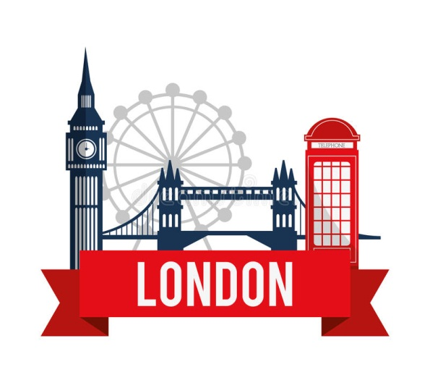
LONDON
London is situated on the river Thames. The city is very old. It was founded in 43 AD by the Roman invaders as a settlement and a fortress. At first it had the name of Londinium. For centuries it was a prominent port through which wealth and prosperity came to the country. In the 11th century London became the capital of England.
The city was built rather chaotically with narrow and dirty streets. In 1666 the Great Fire of London destroyed the most part of the city, which was rebuilt, but the old planning remained untouched.
Historically and geographically London can be divided into four parts: the City, Westminster, the West End and the East End. They are very different from each other.
The City is the oldest part of London, its financial and business center. Numerous banks, offices and firms are concentrated here. Few people live in the City but over a million come to work here.
Westminster is the aristocratic official part of London. There are Buckingham Palace where the Queen lives and the Houses of Parliament along the north bank of the Thames. The clock tower of the Houses of Parliament is famous for its big hour bell known as «Big Ben». Westminster Abbey is the place where the coronation of nearly all kings and queens has taken place. Many of them are buried here as well as some other famous people of the country.
The West End is the richest and most beautiful part of London. The best hotels, restaurants, shops, clubs, parks and houses are situated there. There are many tourists there from different countries of the world. Trafalgar Square is here, it is the geographical center of London, it was named in the memory of Admiral Nelson's victory in the battle of Trafalgar in 1805. The tall Nelson's Column stands in the middle of the square. There is National Gallery behind the column, where you can find paintings by world famous artists.. London's beautiful parks are also in the West End: Hyde Park, St. James' Park are favorite places for Londoners to visit and relax. One may also go shopping in the West End — Piccadilly Street and Oxford Street both present a wide choice of expensive shops and boutiques.
The East End is an industrial district of London. There are many factories there. The region is mostly populated by working class families.
Now London extends much more than the City, the West End and the East End. Its suburbs grow rapidly. London and its suburbs are called Greater London.
As well as it is impossible to say that Moscow is a typical Russian city, nobody can call London a typical British one. In fact, it has become a multinational metropolis, being inhabited by people from all over the world. It is always busy and crowded. It certainly has its own face — millions of faces. Maybe, this is the reason why people say: "When a man is tired of London, he is tired of life.”
Ex. 1 Answer the questions about London.
1. When was London founded?

2. What name did it have at first?
3. Why did the town grow and develop into a city?
4. When did it become the capital of England?
5. What happened to the city in 1666?
7. Name the four parts of London.
8. What part of London is known as the financial centre of the whole country?
9. Are there many attractions in the West End? What are they?
10. Where are Hyde Park, St. James1 Park and Regent's Park situated?
11. What are the most famous places in London to do the shopping?
12. How was the East End transformed recently?
13. What is Greater London?
Ex. 2 Prove that
• London is an old city
• London always played an important role in the life of the country;
• the planning of London is chaotic;
• there are a lot of tourist attractions in the West End;
• the East End has always been different from the rest of metropolis;
• London grows rapidly;
• London is a multinational city.
Ex. 3 Find the map of London and border the parts of London. Put the sights, which are mentioned, onto the map.
Ex. 4 Make up the outline of the text.
Ex.5 Retell the text using the outline and the map.

